P235/1
ISLAMIC
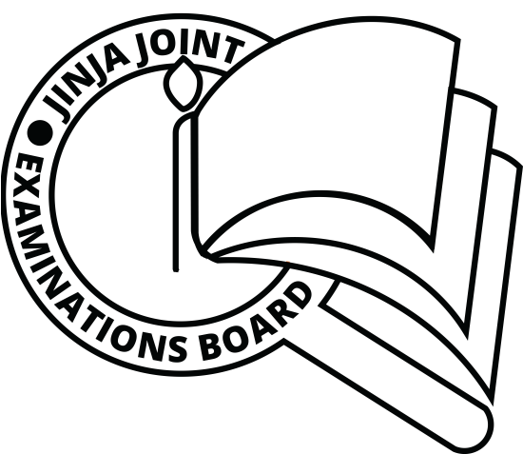
RELIGIOUS
EDUCATION
Paper 1
THE HOLY QUR’AN
DECEMBER, 2020
2½ hours

JINJA JOINT EXAMINATIONS BOARD
Uganda Advanced Certificate of Education
MOCK EXAMINATIONS – DECEMBER, 2020
ISLAMIC RELIGIOUS EDUCATION
THE HOLY QUR’AN

Paper 1

2 hours 30 minutes

INSTRUCTIONS TO CANDIDATES:

Answer any FOUR questions.

ALL questions carry equal marks.

1.Using quranic evidence, account for the revelation of the holy qur’an.
2.Analyse the evidence that show that the holy qur’an was revealed in stages?
3. Life does not end with death but just continues in a new phase, justify this statement.
4. Examine the Qur’anic evidence that prove the historical punishments to different sinners.
5. Discuss the Quranic teachings on the position of a woman in Islam as compared to man.
6. a) Examine the general principles governing a muslim dress.
b) Discuss the social and moral implication of a muslim dress.
7. Explain the rules governing Zakah payment and distribution.
8. a) Discuss the Islamic teachings on ribah
b) How should a muslim avoid ribah
9. Discuss the teachings of the Qur’an governing justice and its administration in an Islamic state.
10. Discuss the rights and obligations of a Muslim leader in an Islamic State.
11. (a) Discuss the uniqueness of Surat Al-fatiha (chapter1)
(b) Explain the meaning of the surah
12 a) Discuss the background of surat al fiil
b) Explain the lessons muslims derive from surat al-fiil

